**ADVANCED JAVA PROGRAMMING**

**SEMINAR**

**TEAM-3**

7. Create a table in the database containing the columns to store book details like: book name, authors, description, price and URL of the book’s cover image. Using JSP and JDBC retrieve the details in the table and display them on the webpage.

**STEPS INVOLVED:**

1. Create a database with the book details in mysql.
2. Using the mysql-connector-java.jar file, connect the database to the jsp program.
3. Get the information in the database and display it , involving both jsp and jdbc.

**SOFTWARE USED:**

1. NETBEANS
2. APACHE TOMCAT
3. NETBEANS
4. PHPMYADMIN
5. BROWSER

**CODES:**

<%@page import="java.sql.ResultSet"%>

<%@page import="java.sql.Statement"%>

<%@page import="java.sql.Connection"%>

<%@page import="java.sql.DriverManager"%>

<%@page contentType="text/html" pageEncoding="UTF-8"%>

<!DOCTYPE html>

<html>

<head>

<meta http-equiv="Content-Type" content="text/html; charset=UTF-8">

<title>JSP Page</title>

</head>

<body>

<center>

<table border ="1">

<tr>

<th> book id</th>

<th>book name</th>

<th>author id</th>

<th>author name</th>

<th>description</th>

<th>price</th>

<th>cover image</th>

</tr>

<%

try{

Class.forName("com.mysql.cj.jdbc.Driver");

Connection con=DriverManager.getConnection("jdbc:mysql://localhost:3306/library", "root", "");

Statement st= con.createStatement();

String str="select * from books inner join author on author.author_id=books.author_id";

ResultSet rs=st.executeQuery(str);

while(rs.next()){

%>

<tr>

<td><%=rs.getString("book_id")%></td>

<td><%=rs.getString("book_name")%></td>

<td><%=rs.getString("author_id")%></td>

<td><%=rs.getString("author_name")%></td>

<td><%=rs.getString("description")%></td>

<td><%=rs.getString("price")%></td>

<td><%=rs.getString("url")%></td>

</tr>

<%

}

}catch(Exception e){

e.printStackTrace();

}%>

</table>

</center>

</body>

</html>

DATABSE:

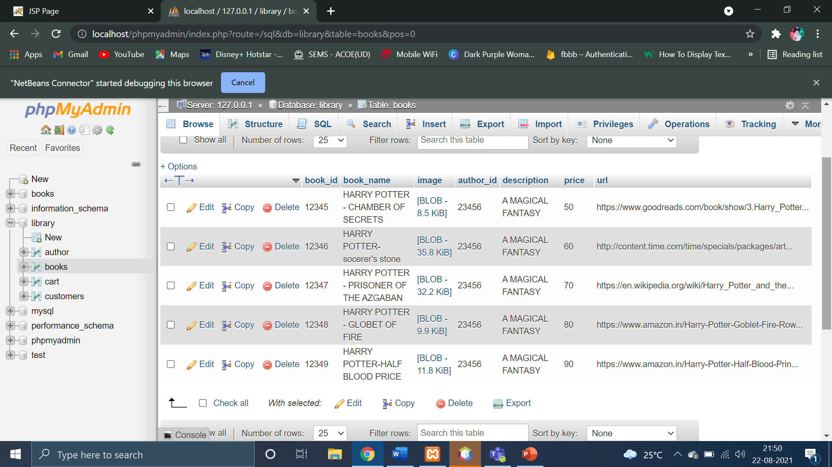

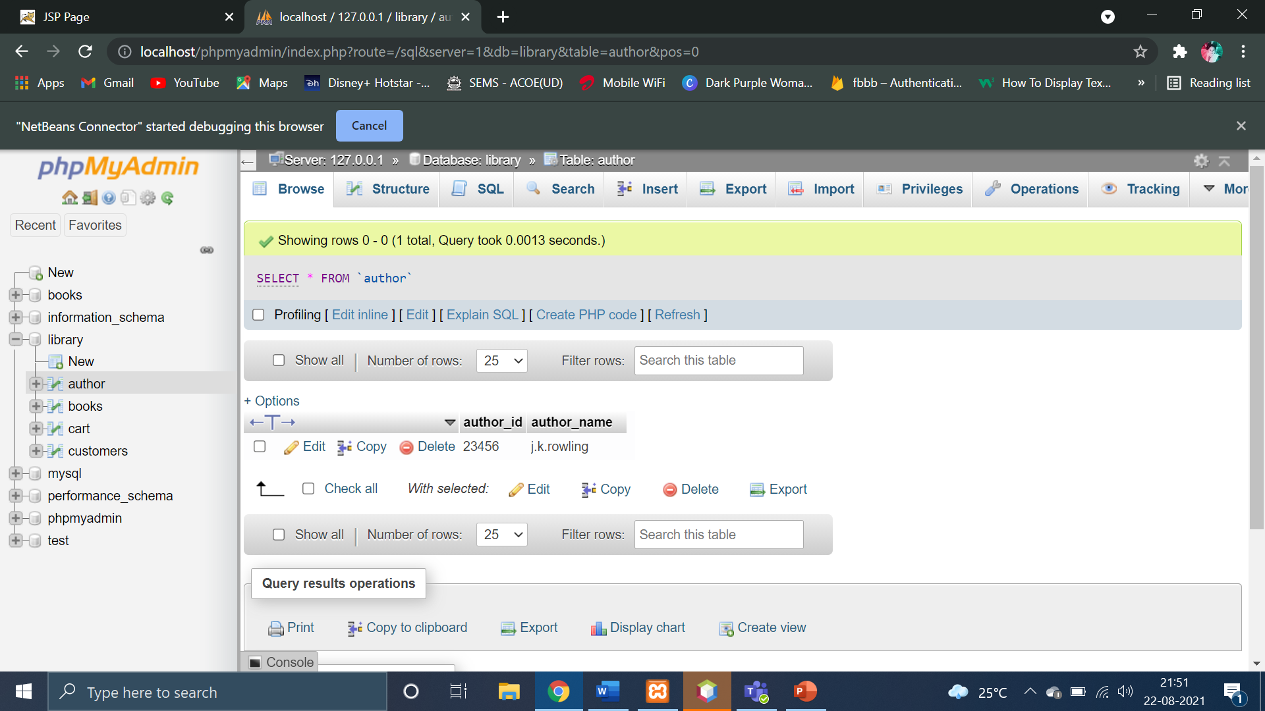

OUTPUT:

